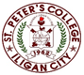

***Committed to Excellence***

St. Peter’s College

042 Sabayle St., Iligan City

**COLLEGE OF COMPUTER STUDIES (SEMINAR AND TOURS)**

**NARRATIVE REPORT ON PLANT SEMINAR (OPTIMIZING PORTFOLIO)**

On the morning of April 6, 2024, at around 9:00 am, the 4th-year students gathered in the computer laboratory, Room A203, for a seminar by Sir Orias. We waited for the rest of our classmates to arrive, and at around 9:30 am, once everyone was present, Sir Orias began the seminar.

Around 9:45 am, Sir Orias discussed how to optimize a portfolio to attract clients, sharing his experiences to provide us with deeper insights into online jobs. He also gave tips on how to start working online, emphasizing the importance of building an organized portfolio.

By 11:30 am, the seminar was drawing to a close. We asked various questions about the topic, and around 11:45 am, the certificate presentation for the speaker began, followed by the closing remarks. Finally, we took photos with Sir Orias as the seminar concluded.

Prepared by:

Edward Jr A. Cabello

       Student

Checked by:

MELLANIE S. GAMBE, MSIT

Dean, College of Computer Studies

Reviewed & Approved by:

MELLANIE S. GAMBE, MSIT

Dean, College of Computer Studies

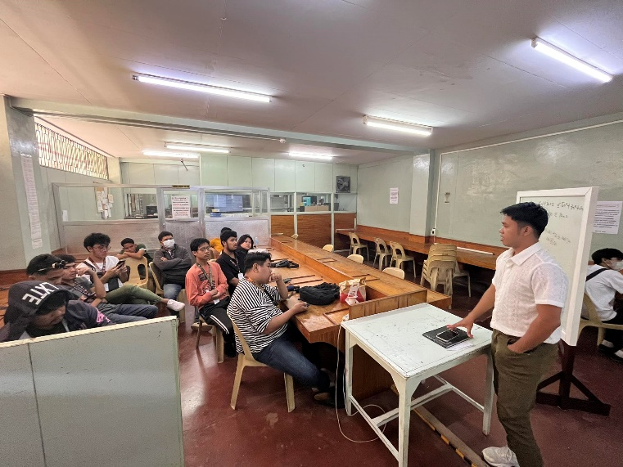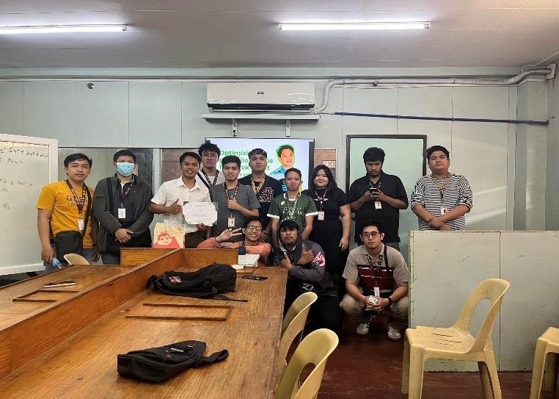

Left: Giving Certificate to speaker.

Right: Sir Orias discussing about the Optimizing Portfolio.